**AUTHOR’S PAGE OUTPUT SNAPSHOTS**

**1. Component Structure in CRXDE**

**Path: apps/myTraining/components/author**

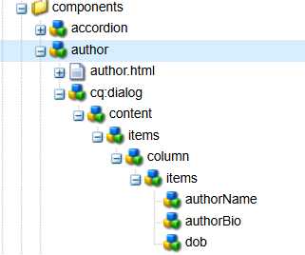

**2. Dialog Configuration in CRXDE**

**Path: /apps/myTraining/components/author/cq:dialog**

***Dialog Structure in CRXDE:***

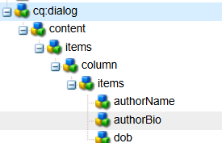

**3. Dialog Fields in AEM Touch UI**

The **dialog** appears in the **AEM Page Editor** when the component is added. The fields capture user input.

<http://localhost:4502/editor.html/content/myTraining/us.html>

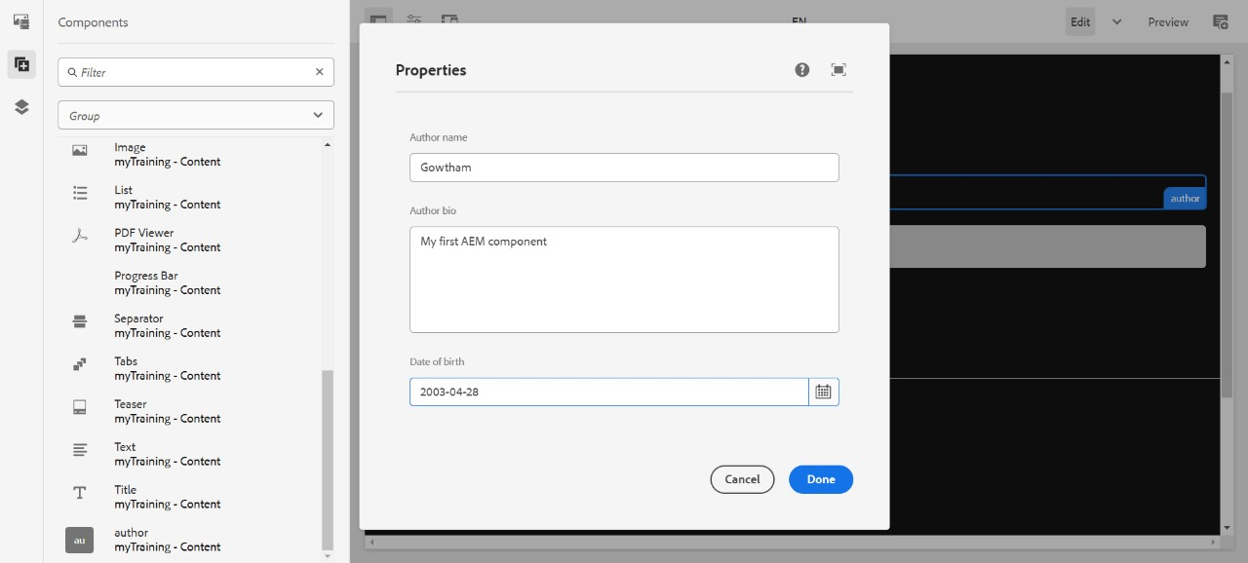

**4. Fetching Values in HTL**

The values are displayed using HTL properties.

***Code in author.html***

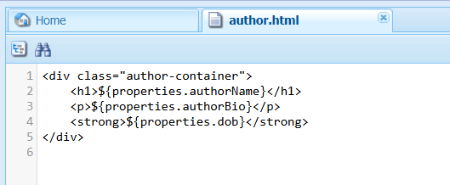

**5. Rendered Component on the AEM Page**

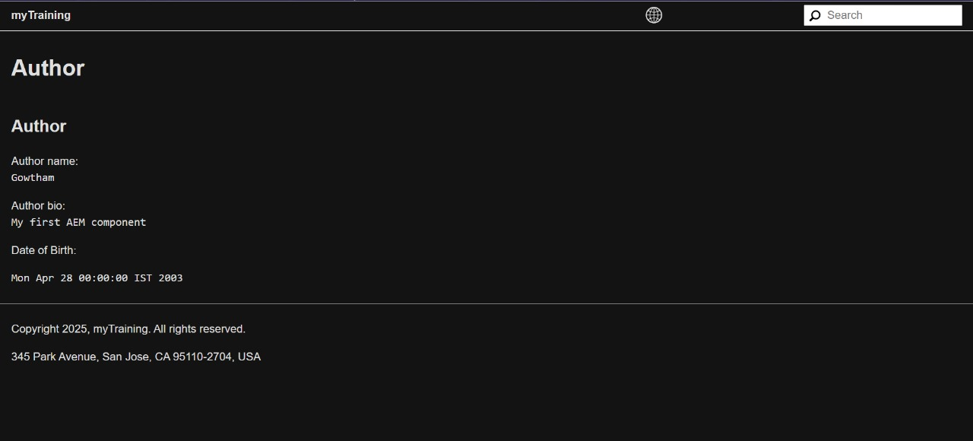

**6. Client Libraries Implementation**

The styles are applied using **Client Libraries** under:  
➡ **/apps/myTraining/clientlibs/author**

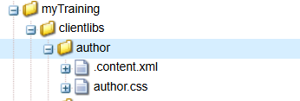

**7. Applying and Verifying Clientlibs**

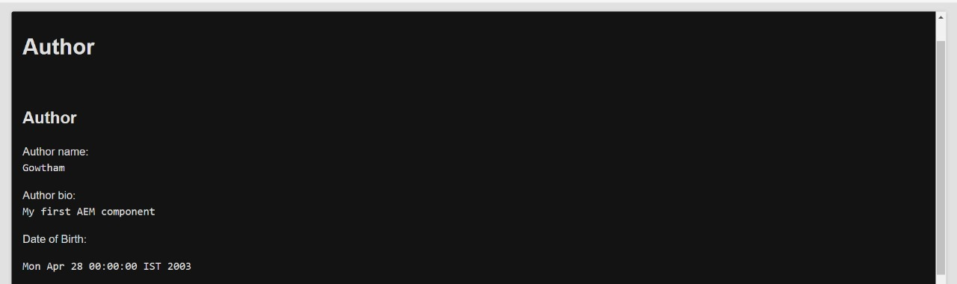

**8. ExtraClientLibs (if implemented)**

extraClientLibs allows loading additional styles/scripts for the component.

